KEPUASAN MASYARAKAT TERHADAP PELAYANAN MTSN 1 BATANG HARI
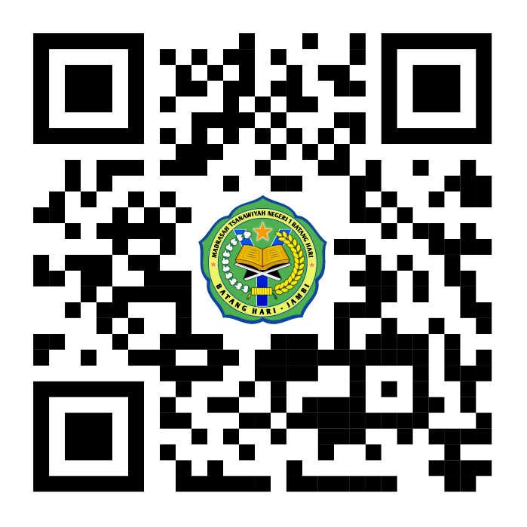

https://docs.google.com/forms/d/e/1FAIpQLSeXA0fVGzhbbKEFHzNt7-bMz3O6adKHgQFYNFUZhA0m4KNxBw/viewform?usp=sharing&ouid=114754582377624431292

